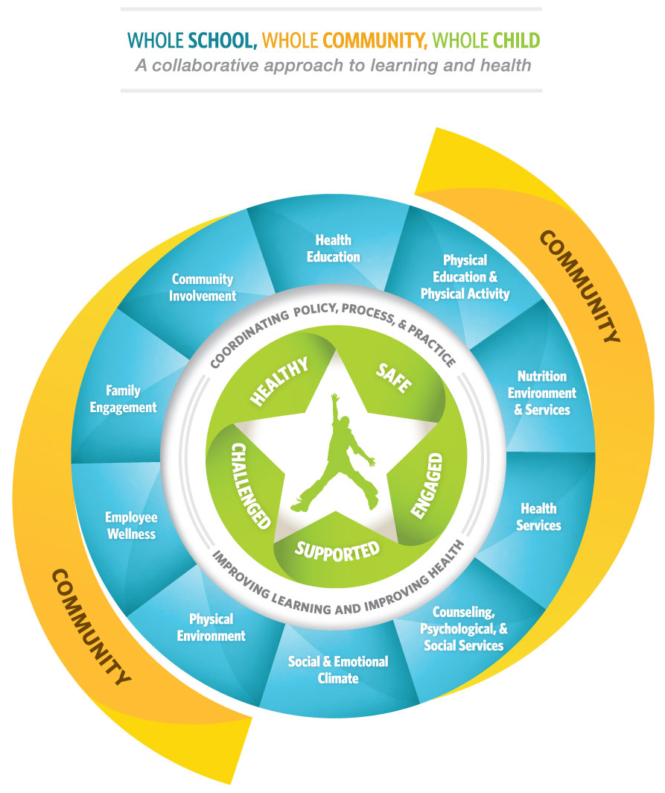
Visit www.ascd.org or wholechild@ascd.org for information regarding the Whole School, Whole Community, Whole Child Initiative.
The SCASCD Whole Child Award

Whole Child Award Application
APPLICATION DEADLINE FOR THE 2023-2024 AWARD PROGRAM IS
Friday, January 5, 2024, by 5:00 p.m.

REQUIRED PAGE
South Carolina ASCD sponsors this award program in support of ASCD Worldwide and The Whole School, Whole Community, Whole Child Initiative. This program seeks to identify schools in South Carolina that have created a school culture with programs that exemplify the five tenets of this Initiative: Healthy, Safe, Supported, Challenged, or Engaged.

Schools applying for the award will be required to submit a completed application, along with supporting evidence to SCASCD, according to program guidelines and timelines. All applications will be reviewed by a selection committee to determine the three finalists. The three finalists will be notified in mid-January. In February, each of the three finalist will receive a site visit from members of SCASCD’s Whole Child Award School Selection Committee. After SCASCD’s annual Spring Conference, the three finalists will be notified of the winning school. The winning school will receive recognition, three complimentary registrations for the South Carolina ASCD Fall Conference, and a banner of recognition.

Criteria:
- Principal must be a member of SCASCD and have been a principal of the applicant school for the entire previous two school years.
- The school’s state accreditation must be in good standing.
- At minimum, the Award School will be expected to offer a breakout session at SCASCD’s annual Whole Child Conference.
- Clearly written goals for each of The Whole School, Whole Community, Whole Child tenets
- Relationship of The Whole School, Whole Community, Whole Child emphasis to the school’s clearly stated vision/mission
- Length of time The Whole School, Whole Community, Whole Child framework has been present at the school
- Evaluation data that measures the success of school’s The Whole School, Whole Community, Whole Child framework.
- Evidence of the degree to which The Whole School, Whole Community The Whole Child framework is being implemented
- Degree of collaboration with stakeholders in promoting the focus of The Whole School, Whole Community, Whole Child framework
Whole Child Award Application

Person Completing this Application:___________________________________________________

Position in the School: ______________________________________________________________

Name of School District: ____________________________________________________________

Name of School: __________________________________________________________________

School Address (street): _____________________________________________________________

Address: ________________________________(city/zip)__________________________________
Phone Number (with area code): ______________________________________________________

School Principal: __________________________________________________________________

Principal’s E-Mail Address: ____________________________ Phone:________________________

District Superintendent: _____________________________________________________________

Email Address:_______________________________________Phone:________________________

Please submit this application with all attachments to Dr. Josh Patterson at jpatterson@greenville.k12.sc.us.

Whole Child Award Application

The Whole Child Initiative
ASCD calls on parents, educators, policymakers, and communities to join forces to ensure our children become productive, engaged citizens. Our children deserve an education that emphasizes academic rigor as well as the essential 21st century skills of critical thinking and creativity.

Specifically, our students must be:
HEALTHY—To ensure that all students are healthy, ASCD recommends, at a minimum:
- Schools have a health advisory council with students, family, community, and business members.
- Students are routinely screened for immunizations and vision, hearing, dental, and orthopedic concerns.
- Physical Education and health classes emphasize lifetime healthy behaviors.
- Healthy food choices are available at school.

SAFE AND SECURE—To ensure that all students are safe, ASCD recommends, at a minimum:
- Students, school staff, and family members establish and maintain behavioral expectations, rules, and routines.
- Families are welcomed by school staff as partners in their children’s education.

ENGAGED—To ensure that all students are adequately engaged, ASCD recommends, at a minimum:
- Students may participate in a wide array of extracurricular activities.
- Schools provide opportunities for community-based apprenticeships, internships, or projects.
- Teachers use active learning strategies such as cooperative learning and project-based learning.

SUPPORTED—To ensure that all students are adequately supported, ASCD recommends, at a minimum:
- Every student has an adult advisor or mentor.
- Students have access to school counselors or other student support systems.
- Each student has access to personalized learning and is supported by qualified, caring adults.

CHALLENGED ACADEMICALLY—To ensure that all students are challenged academically with a well-balanced curriculum, ASCD recommends, at a minimum:
- Schools provide a well-rounded curriculum for all students.
- Students have access to rigorous programs in arts, foreign languages, and social studies.
- Schools maintain flexible graduation requirements.
Whole Child Award Application

Directions:

Complete page 2 and the remaining required pages of the application.

Submit completed application to Dr. Josh Patterson at jpatterson@greenville.k12.sc.us by 5:00 p.m., January 4, 2024.

Please don’t hesitate to contact Dr. Josh Patterson at jpatterson@greenville.k12.sc.us if you have any questions.

Publishing requirements:
- Please use 12 point font (minimum) and Times New Roman font
- Please limit your responses to 500 words or less
- Please submit no more than three (3) exemplars of evidence (i.e. videos, slide shows,
flyers, etc.)
- Please submit no more than three (3) letters of support

REQUIRED PAGE

School Name: ____________________________

What is your school’s vision/mission statement?

School Information:

Type of School: Rural Suburban Urban

Grade levels served by this school:

K-5 7-8 9-12

K-6 6-8 10-12

5-8 7-12

Other _______________________ (indicate grade range)

Student Demographics:

Demographic | Number of Students in this School | Percentage of Students in this School
White Students
African-American Students
Hispanic Students
Asian Students
Native American Students
Other Students
Male Students
Female Students
English Language Learners
Students with Disabilities
Migrant Students
Participants in G&T Programs
Homeless
Free and Reduced Lunch

REQUIRED PAGE

School Name: __________________________

Staff Demographics:

Total Number of Teachers
Total Number of Administrators
Principal
Assistant Principal(s)
Other (Please Specify)

Briefly describe any special or support staff assigned to your building.
___________________________________________________________________________________________________________________________________________________________________________________________________________________________________________________

The questions on the following page(s) will be used to determine if your school is eligible for consideration for the award. These questions will also link directly to documentation you may wish to provide in support of your application (such as videos, articles, etc.). Include how you developed the practice, who benefits, and evidence of your success. Please note that your answers will be scored based on how well they demonstrate vision, intentionality, integration, and sustainability of the best practice, in addition to how the practice engages and empowers stakeholders.

REQUIRED PAGE

Required Questions for the Tenet: Challenged

School Name: _____________________________________________________

In answering the following questions, be specific about programs that have emphasized developing higher order thinking skills, collaboration, problem solving, differentiated instruction, and student motivation, etc. for all students.

Answer each of the following questions in 500 words or less:

- What specific programs do you have in place that goes above and beyond the norm to address the needs of all academic levels of students? Please provide a brief description.

- What effects have these strategies or actions had on students’ achievement and overall growth and success (e.g., academic performance, attendance, family engagement, and health indicators)?

Required Questions for the Tenet: Engaged

In answering the following questions, be specific about school programs that emphasize a wide array of extracurricular activities; community-based apprenticeships, internships, or projects; cooperative learning, project based or other engaging activities.

Answer each of the following questions in 500 words or less:
- Please describe programs and activities designed to engage students and include how they are organized so they are accessible for all students.

- What partnerships with community entities do you have in place that provide for the needs and interests of your students? What partnerships with parents and families do you have in place that provide for the needs and interests of your students?

REQUIRED PAGE

Required Question for the Tenet: Safe

In answering the following questions, be specific about school programs that emphasize safe topics such as internet safety, making safe choices, training regarding emergency procedures, bicycle safety, safe driving, gang awareness, dangers of drugs and alcohol, and/or school/community safety.

Answer each of the following questions in 500 words or less:
- How have you provided safety related programs or experiences for your students, parents, or community members that address current and ongoing safety issues such as the ones mentioned above?

Required Questions for the Tenet: Healthy
In answering the following questions, be specific about school programs that emphasize a healthy lifestyle. Describe policies and programs that emphasize healthy eating, rest, stress reduction, cardiovascular fitness, sexually transmitted disease prevention, use of harmful substances, personal and social responsibility and any others.

Answer each of the following questions in 500 words or less:
- Describe programs you have provided for your students, faculty, and/or parents/community that address topics related to the tenet healthy.

REQUIRED PAGE

Required Questions for the Tenet: Supported

In answering the following questions, be specific about programs that emphasize how you support, differentiate and personalize learning for your students.

Answer each of the following questions in 500 words or less:
- Describe programs that support all students above and beyond requirements. Explain how students have access to personalized learning and are supported by qualified, caring adults.

- Describe programs that engage or involve parents or the community in supporting students academically, socially, and emotionally.

Additional Required Questions
- Provide a specific description of professional development activities provided for your professional support staff which addresses at least two or more of the five tenets.

- Provide a one page statement of why you believe your school should be selected for this award.

REQUIRED PAGE

School Name: ______________________________

You may submit a maximum of three (3) letters of support for your school from any of the following: superintendent, PTA/PTO President, parent(s), student(s), community agency or anyone else that supports your school.

PERMISSION FORM

We give permission for SCASCD to publish information included in this application in order to assist other schools in developing and implementing their school programs.

This information may also be shared with and published by National ASCD headquartered in Alexandria, Virginia.

We also give SCASCD permission to take photos of any students in our school with the exception of those covered by parent permission not to be photographed.

As the Principal of ____________________________, I approve of this award program submission.

_______________________________________ _________________________________
Principal’s Signature Date

_______________________________________ _________________________________
Superintendent’s Signature Date

Schools that are awarded the grant will be recognized at the SCASCD Fall Conference and will be required to prepare a brief presentation to be shared at the conference.

Please submit this application to Dr. Josh Patterson at jpatterson@greenville.k12.sc.us.

Deadline for Submission: Friday, January 4, 2024 @ 5:00pm

